CSC505 Module 5 Critical Thinking
Michael McPherson
Colorado State University, Winter-B
CSC505-1 Principles of Software Development
Module 5
Dr Douglas Mujeye
22 January 2025

Introduction:
The Pothole Tracking and Repair System (PhTRS) is a tool for the general public to report potholes (size location, and remarks) to their local municipality. It’s purpose is to streamline reporting, and increase the efficiency of pothole repair. This program is written in python and revolves around three primary actors: The people, The office staff and the repair crew. Each actor plays a vital role in the maintenance and repair of potholes. It starts when a member of the public finds a pothole. They then log onto the system and enters in some basic information about the pothole into the UI/UX. The program checks the work queue, merges duplicate requests. This is just the beginning stages of the build, future iterations will allow the office staff then uses that information to assign a work crew, assign materials for the repair and then schedule the repair. Once Materials and and a crew are assigned, the crew arrives on site, makes the necessary repairs, updates the database with the status of the repairs.
Main Flow:
The Main Workflow Preconditions:
The main workflow starts when a citizen logs onto the PhTRS and enters in a detailed report on a pothole, including name, street address of the pothole, and a description. This is the primary access point for the PhTRS system. The UI/UX will eventually be equipped with maps, logging systems, and scheduling systems. These features would be critical in maintaining a localities roads.
This data is then processed by the municipality’s maintenance office staff. Once the crew is assigned, they arrive on site, make the repairs and update the status of the work order. Citizens will then be able to track the repair status. Once complete the office staff will be able to process the data and update the database. The database will store the PhTRS system data and allow the staff to produce reports.

Alternative Flow:
The PhTRS system is designed to handle exceptions to the user inputs through an alternative flow. For example. If a duplicate pothole report is made, the program will merge the two reports in to a single report. Being in its infancy, future versions will include a way for the crew to input If there is a delay in the repairs the crew is able to update the status of the repairs in real time. These status updates will show the citizen the reason fro the repair delay, as well as allow the staff, among other things, to run reports on the delays. Furthermore, User Inputs are stripped of their capitalization and formatting from the beginning in order to stabilize the system.
Post conditions:
Once the repairs are complete the system ensures that the database is up to date with data in real-time. Being a transparent system which will enhance user/public trust and user satisfaction. In it’s final production version the system will have
Nonfunctional Requirements:
Outside of the core functionality, the PhTRS’ design is such, that it meets several non-functional
requirements. The system will be compatible with various operation systems and mobile devices to support the greatest number of actors. Te system will be upscale-able and allow for future expansion by adding in other localities/districts. Data security is always of high concern in any system that holds user data, therefore security will always be of the highest concern, Finally, the system must also comply with local, state and federal legal regulations.
Conclusion:
The PhTRS is an innovative application that creates a practical solution to the maintenance of a localities roads. Currently road maintenance and pothole repair is an inefficient manner of management. This program will streamline notification of needed repairs. This is done by combining a dynamic and robust user input handling practices and efficient workflows. It has a focus on scalability compatibility, and data security in order to ensure that it can be adapted to the ever evolving needs of both the people, the staff and the repair crews.

References:
About merge methods on GitHub - GitHub Docs. (2025). GitHub Docs.
https://docs.github.com/en/repositories/configuring-merges-in-your-repository
Bojic, D., & Velasevic, D. (2001). A Method for Reverse Engineering of Use Case Realisations in UML. Australasian Journal of Information Systems, 8(2). https://doi.org/10.3127/ajis.v8i2.237
Pressman, R. S., & Maxim, B. R. (2020). Software engineering: A Practitioners Approach.
Mcgraw-Hill Education.
Appendix A: UML Diagrams:
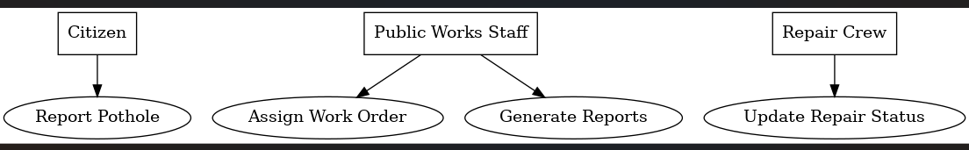
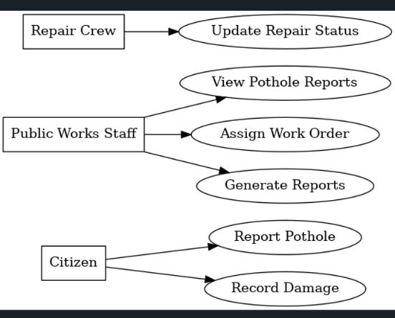

Appendix B: Code:
'''
# Pothole Tracking System.
# Use Python to write a script that will print out the different actors and use cases
# actors: The People, The office staff & Road Crew.
# Preconditions: Internet access (ALL), UI/UX System, (ALL), Computing system (ALL), Ui/UX must have mapping and logging sytem, as welll as a schedule, and and a materials and work database
# Main Flow:
- Complaintant logs onto the UI/UX,
- Submits a complaint report,
- Staff reads the report, assigns crew, materials, anad shedules repairs.
- Crew arrives at work site, makes repairs, updates the UI/UX with status/completion
- Staff updates the UI/UX system/database.
# Alternative Flow:
- If duplicate report is made, merges complaints
- If crew is delayed, can't fiish/fix the hole, it logs a reason and changes status.
# Postconditions:
- Status' are kept up to database
- People are can access job status and times of work, as well as future work
# Non-functional Requirements
- UI/UX must be compaltible with numerous sysytems, Web/Android/apple
- UI/UX must comply with the law
- expandability, sytem must be able to add in new districts.
- System should be able to handle the digital volume.
- Data security, Ui/UX communication and database systems must me secure to ensure customer data protection.
'''
# Pothole Tracking System
# Actors: The People, The Office Staff & Road Crew.
# Create a dictionary for actors
actors = {
'people': "The People",
'office_staff': "The Office Staff",
'road_crew': "Road Crew"
}

# Create a dictionary for the use cases
use_cases = {
'report_pothole': "Report Pothole",
'add_pothole': "Add Pothole",
'assign_pothole': "Assign Pothole",
'assign_crew': "Assign Crew",
'assign_materials': "Assign Materials",
'crew_arrives': "Crew Arrives",
'verify_pothole': "Verify Pothole",
'fix_pothole': "Crew Fixes Pothole",
'update_pothole': "Update Pothole Status",
'pothole_report': "Create Pothole Report",
'remove_fixed_pothole': "Remove Fixed Pothole from the list",
'close_pothole': "Close Pothole Report"
}

# Create a dictionary for the pothole work queue
work_queue = []

# Accept user inputs
def people_input():
name = input("Enter your name: ").strip()
print(f"Hello {name}, welcome to the Pothole Tracking and Repair System.")

while True:
report = input("Would you like to report a pothole? (yes/no): ").strip().lower()
if report == "yes":
address = input("Enter the address of the pothole: ").strip()
diameter = input("Enter the diameter of the pothole (in inches): ").strip()
depth = input("Enter the depth of the pothole (in inches): ").strip()
comments = input("Enter any additional comments: ").strip()

# Add the pothole data to the work queue
pothole_data = {
"address": address,
"diameter": diameter,
"depth": depth,
"comments": comments
}
work_queue.append(pothole_data)
print("Thank you for reporting the pothole. It has been added to the work queue.")
elif report == "no":
print("Thank you for visiting the Pothole Tracking and Repair System. Goodbye!")
break
else:
print("Invalid input. Please enter 'yes' or 'no'.")

# Function to print actors and use cases
def print_PhTS():
try:
print("\nPothole Tracking and Repair System - Actors:")
for actor, description in actors.items():
print(f'- {actor}: {description}')

print("\nPothole Tracking and Repair System - Use Cases:")
for use_case, description in use_cases.items():
print(f'- {use_case}: {description}')
except Exception as e:
print(f"An error occurred while printing system details: {e}")

# Main function
def main():
try:
print_PhTS() # Print actors and use cases
people_input() # Ask for user inputs
print("\nCurrent Work Queue:")
for idx, pothole in enumerate(work_queue, start=1):
print(f"{idx}. Address: {pothole['address']}, Diameter: {pothole['diameter']} inches, Depth: {pothole['depth']} inches, Comments: {pothole['comments']}")
except Exception as e:
print(f"An error occurred in the main function: {e}")

# Call the main function
if __name__ == "__main__":
main()

Appendix C: Compile.
mikea@PCSP-1NWYCP2 MINGW64 ~/Desktop/CSU-MSAI/CSC505 Principles of Software Development
$ C:/Users/mikea/AppData/Local/Microsoft/WindowsApps/python3.12.exe "c:/Users/mikea/Desktop/CSU-MSAI/CSC505 Principles of Software Development/Module 4/Module 5/csc505_McPhersonM_module5_CT.py"

Pothole Tracking and Repair System - Actors:
- people: The People
- office_staff: The Office Staff
- road_crew: Road Crew

Pothole Tracking and Repair System - Use Cases:
- report_pothole: Report Pothole
- add_pothole: Add Pothole
- assign_pothole: Assign Pothole
- assign_crew: Assign Crew
- assign_materials: Assign Materials
- crew_arrives: Crew Arrives
- verify_pothole: Verify Pothole
- fix_pothole: Crew Fixes Pothole
- update_pothole: Update Pothole Status
- pothole_report: Create Pothole Report
- remove_fixed_pothole: Remove Fixed Pothole from the list
- close_pothole: Close Pothole Report
Enter your name: Michael McPherson
Hello Michael McPherson, welcome to the Pothole Tracking and Repair System.
Would you like to report a pothole? (yes/no): yes
Enter the address of the pothole: 123 Main st, Fountain, CO 80817
Enter the diameter of the pothole (in inches): 24
Enter the depth of the pothole (in inches): 6
Enter any additional comments: large pothole that can damage cars.
Thank you for reporting the pothole. It has been added to the work queue.
Would you like to report a pothole? (yes/no): no
Thank you for visiting the Pothole Tracking and Repair System. Goodbye!

Current Work Queue:
1. Address: 123 Main st, Fountain, CO 80817, Diameter: 24 inches, Depth: 6 inches, Comments: large pothole that can damage cars.

mikea@PCSP-1NWYCP2 MINGW64 ~/Desktop/CSU-MSAI/CSC505 Principles of Software Development
$
C:\Users\mikea\Desktop\CSU-MSAI\CSU_MSAI_GitHub\CSC505 Principles of Software Development

